Doxy.me – Desktop Quick Guide
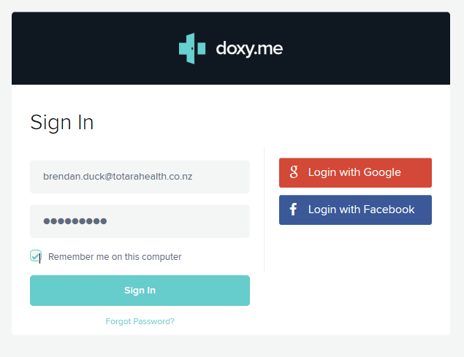
Use on windows or mac with access to a camera, speakers and microphone. Google Chrome (Windows) or Safari (Mac) are supported.
- Open Chrome or Safari
3
- Go to sign in page https://doxy.me/sign-in
- Use login details provided by Health HB or
Practice. HINT this will be an e-mail address
TIP: Select remember me if only you use this
device.
- Turn on Webcam
- Allow doxy.me to use microphone and camera
- Patients waiting will be in the queue on the left
hand menu.
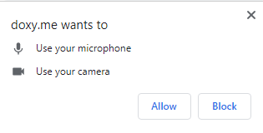
- Select your patient from the waiting room
- Click start call
- If there is a patient, you are not expecting click
On the 3 dots. Select remove.
NB: If the patient has an ! beside the video
You will not be able to see them, they will
5
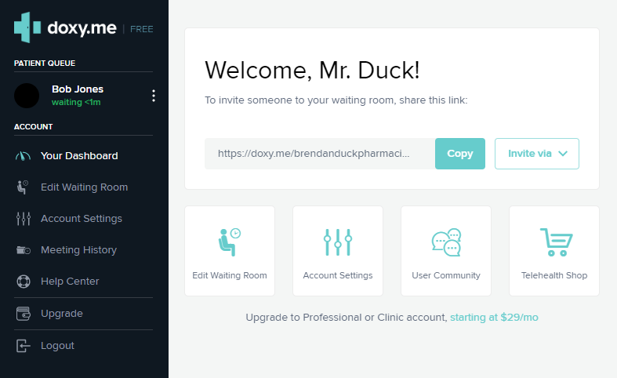
Still see you.
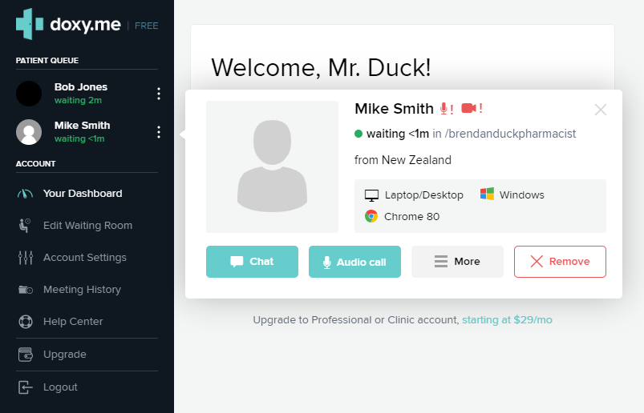
6
9

