Free E-Therapy Tools
Recommended by MoH, Mental Health Foundation, NZGP
Resource and Link | Description
1737 Need to Talk  1737.org.nz  Free text or call 1737 | Talk to a trained counsellor for free, anytime. When someone texts or calls 1737 a counsellor will work with the person to develop a care plan. This could include referral to another service, additional counselling or provision of information and support.
Especially For Youth
The Lowdown  thelowdown.co.nz  Free Call: 0800 111 757  Free text 5626 | An interactive website for young people featuring a self-test, fact sheets, a moderated message board and video clips from high profile young people talking about their experiences of depression.  Support: The site gives access to a team of counsellors who provide email, phone, webcam and text-based support services for young people. Peer support in moderated forums.  Culturally Inclusive: Māori & Pasifika - Aunty Dee
What’s Up  whatsup.co.nz  Free call: 0800 942 8787 | For ages 5-18. Phone Counselling is available Monday to Friday midday – 11pm and weekends, 3pm-11pm. Online chat is available from 5pm-11pm 7 days a week, including all public holidays.
Aunty Dee  auntydee.co.nz | A free online tool for anyone who needs some help working through a problem.  Support: Sympathetic static guide  Culturally Inclusive: Māori & Pasifika designed but appropriate for all ethnicities
Youthline  youthline.co.nz  Free call: 0800 376 633  Free Text: 234  Email: talk@youthline.co.nz | Call or online chat 11am-11pm 7 days a week
SPARX  sparx.org.nz  Free Call: 0508 477 279  Free text: 3110 | An interactive self-help online tool that teaches young people skills to help combat depression and anxiety. Uses a 3D fantasy game environment.  Support: Avatar/virtual therapist. Youthline and Lifeline support via text or phone.  Culturally Inclusive: Māori & Pasifika design but appropriate for all ethnicities because of customisable avatar.
Kidsline  0800 5430754 | For young people up to 18 years of age. Open 24/7
RainbowYOUTH  ry.org.nz | Dedicated to helping young queer and gender diverse (LGBTIQ) people up to the ages of 27, as well as their wider communities. Services: Information, Advocacy, Schools & Professional Development, Peer-support groups, Referrals, Consultation, Training & youth development.
Mental Health Services
Depression.org  depression.org.nz  Free text 4202  Free Call: 0800 111 757 | This website helps New Zealanders recognise and understand depression and anxiety. Includes The Journal (Adult) and The Lowdown (Youth) – online self-help programmes.  Support: 24 hour support via Telepresence – text, email, phone with trained counsellors  Culturally Inclusive: Māori & Pasifika
The Journal [NZ]  depression.org.nz | A free, personalised online programme for adults with depression or anxiety. JK, alongside mental health experts, act as guides through a series of online lessons.  Support: Telepresence – text, email, phone with trained counsellor  Culturally Inclusive: Māori & Pasifika
Beating the Blues  beatingtheblues.co.nz | Treats depression and anxiety by using cognitive behavioural therapy (CBT).  Educational programme – would require supportive follow up. Feedback to GP if concerns are raised by person’s responses. Requires doctor referral.  Culturally Inclusive: Māori & Pasifika
Like Minds, Like Mine  likeminds.org.nz  Take the load off  taketheloadoff.nz | A public awareness programme to increase social inclusion and end discrimination towards people with experience of mental illness or distress.  Support: Links to help if you have been discriminated against.  Culturally Inclusive: Māori & Pasifika
LeVa  leva.co.nz  facebook.com/LeVaPasifika | Support Pasifika families and communities to unleash their full potential and have the best possible health and wellbeing outcomes. Education and information.
Drug Help  drughelp.org.nz | A programme of the NZ Drug Foundation. Contains information and tools for people concerned about the negative effects of substance use.  Support: Confidential helplines are available 24 hours a day, 7 days a week, free from landline or mobile.  Alcohol Drug Helpline: 0800 787 797 | www.alcoholdrughelp.org.nz  Maori Helpline: 0800 787 798  Pasifika Helpline: 0800 787 799
OUTLine  outline.org.nz  0800 OUTLINE (688 5463) | Confidential and self-affirming LGBTIQ+ telephone support and face-to-face counselling. Information and resources.
Apps
Mentemia | An app developed by All Blacks legend and mental health champion Sir John Kirwan. A mental wellbeing coach in the palm of your hand, Mentemia is available on your phone 24/7. It gives you the ability to monitor, manage and improve your mental health. The app allows you to set goals and track progress in much the same way other apps help you to track your physical fitness and health. Mentemia was originally developed for workplaces but it is currently available to all New Zealanders until the end of September.
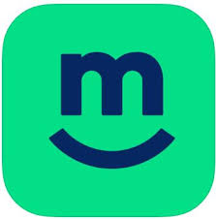  Melon | An app that provides a safe space for you to connect with and support other New Zealanders to uplift your emotional wellbeing. The app provides access to an online community, daily webinars to support mental health and wellbeing, a health journal, tools to check in with yourself about how you’re feeling and podcasts, videos and articles to help you learn more about how you can look after your mental health and wellbeing.
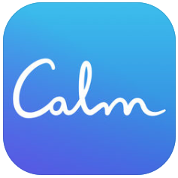  CALM  iPhone  Android | Calm was branded as Apple's "App of the Year" in 2017. The app is designed to reduce anxiety, improve sleep, and help you to feel happier. Calm focuses on the four key areas of meditation, breathing, sleep, and relaxation, with the aim of bringing joy, clarity, and peace to your daily life. The app delivers meditations that can help you to destress, as well as breathing programs, music, and sounds from nature to relax your mind and body and promote better sleep. Calm is the perfect app if you are new to meditation, but it also offers programs for more advanced users. Meditation sessions are available in lengths of 3–25 minutes, to fit in with your schedule. *Free
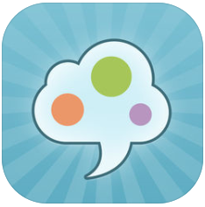  Sam  iPhone  Android | One of 2018’s Best Anxiety Apps. SAM is a friendly app that offers a range of self-help methods for people who are serious about learning to manage their anxiety. SAM has been developed by a university team of psychologists, computer scientists and student users. Established methods of self-help have been combined with high standards of usability to provide an engaging, flexible, and practical resource. *Free
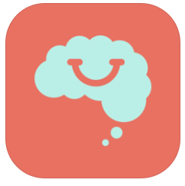  Smiling Mind  iPhone  Android | Smiling Mind is a free web and app-based program developed by psychologists and educators to help bring balance to people's lives. Just as we eat well and stay fit to keep our body healthy, mindfulness meditation is about mental health and looking after the mind. Smiling Mind is a 100% not-for-profit organisation that works to make mindfulness meditation accessible to all. Our vision is to help every mind thrive. Our mission is to provide accessible, life-long tools to support healthy minds. *Free
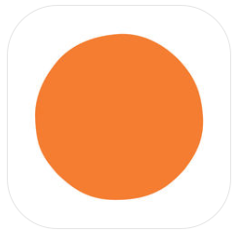  Headspace  iPhone  Android | Headspace is the simple way to reframe stress. Sleep trouble? Meditation creates the ideal conditions for a good night’s rest. Relax with guided meditations and mindfulness techniques that bring calm, wellness and balance to your life in just a few minutes a day. Get more from your day through mindfulness, be less distracted and reactive, and focus on the things that matter most to you. *Free
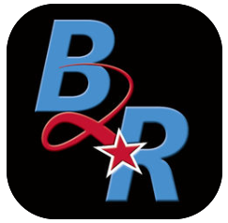  Breathe2Relax  iPhone  Android | Breathe2Relax is a portable stress management tool which provides detailed information on the effects of stress on the body and instructions and practice exercises to help users learn the stress management skill called diaphragmatic breathing. Breathing exercises have been documented to decrease the body’s ‘fight-or-flight’ (stress) response, and help with mood stabilization, anger control, and anxiety management. *Free
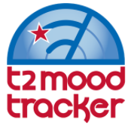  T2Mood Tracker  iPhone  Android | Mood Tracker allows users to monitor their moods on six pre-loaded scales (anxiety, stress, depression, brain injury, post-traumatic stress, general well-being). Custom scales can also be built. Users rate their moods by swiping a small bar to the left or to the right. The ratings are displayed on graphs to help users track their moods over time. Notes can be recorded to document daily events, medication changes and treatments that may be associated with mood changes, providing accurate information to help health care providers make treatment decisions. *Free
Virtual Hope Box  iPhone  Android | The Virtual Hope Box (VHB) is a smartphone application designed for use by patients and their behavioral health providers as an accessory to treatment. The VHB contains simple tools to help patients with coping, relaxation, distraction, and positive thinking. Patients and providers can work together to personalize the VHB content on the patient's own smartphone according to the patient's specific needs. The patient can then use the VHB away from clinic, continuing to add or change content as needed. *Free
What’s Up  iPhone  Android | What's Up? is a fantastic free app utilising some of the best CBT (Cognitive Behavioural Therapy) and ACT (Acceptance Commitment Therapy) methods to help you cope with Depression, Anxiety, Anger, Stress and more! With a beautiful, modern design, simple heading and easy-to-follow methods, you can get to what helps you the most in seconds! *Free
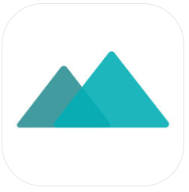  Moodpath  iPhone  Android | Moodpath is your pocket-sized mental health companion. Whether you are facing a rough patch or have concerns about your mental health, the app's goal is to support you through the difficult times and guide you out the other side. Moodpath asks daily questions in order to assess your well-being and screen for symptoms of depression. The screening progress aims to increase your awareness of your thoughts, emotions, and feelings. After a period of 2 weeks, the app generates an electronic document that you can discuss with a healthcare professional. More than 150 videos and psychological exercises are available to help you understand your mood and strengthen your mental health. *Free
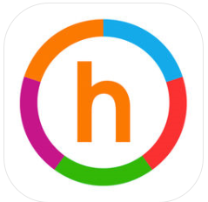  Happify  iPhone  Android | Feeling worried or stressed? Or maybe it’s something more severe? This app aims to give users an instant lift with activities and games to elevate your happiness level. It also includes guided meditations and personalized programs. The visual charts let you track your progress so you can get a sense of how you’re doing overall, based on evidence-based interventions. For even more, Happify Pro is available as a monthly paid subscription. *Free
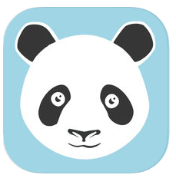  MoodPanda  IPhone  Android  Web | MoodPanda lets you to measure your daily moods and track the scores over time. You can connect to Twitter or Facebook to share your scores and be part of the supportive Moody Pandas community.

