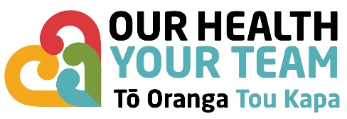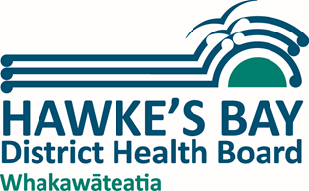

Ehara taku toa i te toa takitahi. Engari, he toa takitini.
Success is not the work of one, but the work of many.

Permanent
0.6 FTE / 34hrs week

The importance of Public Health to the health and well being of our communities has never been more clear than over the last few years. Hawke’s Bay District Heath Board is offering a great opportunity to join a growing Public and Population Health team that is increasingly recognized as a centre of excellence in Public Health practice. The role will provide an excellent opportunity for someone with General Practice or Child Health experience to develop a special interest in Public Health and work in a very collegial work environment. You will not require vocational registration although vocational registristion in General Practice would be welcome.

You will join a Public Health Clinical team consisting of three Public Health Medicine Specialists, a Registrar, and a House Officer and will work closely with our Health Protection and Child Health teams with support from your clinical colleagues

You will be passionate about improving the health and wellbeing of our people and reducing the health inequalities in our community.

Your strengths will include:
- Sound clinical skills and judgement particularly in relation to vaccine preventable and other communicable diseases
- A proven ability to contribute to effective team work
- An ability to think strategically, conscious of the ‘bigger picture’ and the long-term future for public health services and the implications of this for Hawke’s Bay.
- An ability to build networks and partnerships
- Excellent written, oral and interpersonal skills, including the ability to apply them to the area of community consultation and liaison.

Through our values here at HBDHB, we are proud of our team’s diversity. We believe in the strength of a diverse and inclusive workforce, to help us achieve the best outcomes for our patients and the communities in which we operate and serve. Our values are He kauanuanu – Respect, Ākina – Improvement, Raranga te tira – Teamwork and Tauwhiro – Care.

We have no doubt that you would love everything Hawke’s Bay has to offer: the stunning climate and beaches; the wide range of sporting and leisure opportunities; the art, wine, food and culture; and an environment and work/life balance that are second to none. Take a stroll through the Hawke’s Bay Tourism website and get yourself to Hawke’s Bay!

Eligibility

- You will have eligibility for general or provisional general registration with the Medical Council of New Zealand. Information on the process of application for this can be found on their website at http://www.mcnz.org.nz/
- You will need to be a NZ or Australian citizen or resident, or have an appropriate visa to be eligible to live and work in NZ. The Immigration NZ website can be found at:
https://www.immigration.govt.nz/new-zealand-visas

If you have any questions about this position, please contact Dr Nicholas Jones Clinical Director, Health Improvement and Equity Directorate by e-mail: nicholas.jones@hbdhb.govt.nz

