Suspected DVT Lower Limb

This guideline provides support for DVT lower limb investigation and management within primary care. This is to be used for guidance only and should not replace clinical judgment.

SUSPECTED DVT
- Please do not refer patients with suspected DVT lower limb to the Emergency Department at HBDHB. If unsure clinically, then please refer to a colleague i.e.: at a local A&M Centre for assessment. There will be no claw backs.
- There will be times when an ultrasound scan is not available on the same day (e.g., weekends and evenings) and therefore a clinical decision needs to be made to commence enoxaparin prior to scan availability. This is the same process that is followed at the HBDHB Emergency Department.
- For suspected DVT, enoxaparin is available under a Special Authority application, SA0975. When using Special Authority also include CPO number on prescription and the dispensing fee will be charged back to CPO.
- Patient is discharged from CPO once the patient is commenced on anticoagulant therapy.

Indications for Investigation:
- 1st symptomatic? DVT; - High risk asymptomatic;
- Recurrent symptomatic DVT; - Chronic symptoms,? Diagnosis - Pulmonary Embolism, asymptomatic leg symptoms.
Red Flags/ Refer if:
- Under 18
- Pregnant
- Possible proximal VT
- DVT other than lower limb
- Clotting disorders
- On dialysis
DVT SIGNS AND SYMPTOMS
- Unilateral Oedema
- Erythema
- Localised tenderness of deep venous system thigh or calf
- Calf swelling > 3.0cm cf asymptomatic leg
Risk Factors for DVT
- Surgery in last 12 wks
- Immobilised >2/7 last 4 wks
- # leg, POP, in last 12 wks
- Strong FH or PH DVT/PE
- Cancer
- Post partum
- Lower extremity paralysis or
trauma
- Obesity - Stroke
- Oestrogens
Alternative Conditions:
- Superficial Thrombophlebitis
- Achilles tendon strain/rupture
- Calf muscle injury
- Cellulitis
- Baker’s Cyst intact / ruptured
- Cardiac related oedema
- Pelvic obstruction
- Lymphoedema lymphangitis
- Drug induced oedema
- Venous valve insufficiency
- Undiagnosed Malignancy
FOLLOW-UP SCANS

There is no indication for repeat scanning of legs following treatment of DVT in the community

ASSESSMENT

Clinically examine and score the patient using the Wells Score below. Follow the algorithm according to low probability (1 or less) or High probability (2 or more).

WELLS SCORE

CLINICAL FEATURE (WELLS) SCORE
Active cancer (treatment ongoing or within previous six months or palliative) | 1
Paralysis, paresis or recent plaster immobilisation of lower extremities | 1
Recently bedridden >3 days or major surgery within four weeks | 1
Localised tenderness along the distribution of the deep venous system | 1
Entire leg swollen | 1
Calf swelling 3cm > asymptomatic side
(measured 10cm below Tibial Tuberosity) | 1
Pitting oedema confined to the symptomatic leg | 1
Collateral superficial veins (not Varicose) | 1
Alternative diagnosis as likely as or greater than that of DVT | -2
Risk score interpretation (probability of DVT):
- >/=3 points: high risk (75%);
- 1 to 2 points: moderate risk (17%);
- <1 point: low risk (3%).

Recommended follow-up procedure:

If a clear alternative diagnosis
- (Bakers cyst, cellulitis, muscle strain, oedema) No active follow-up required.

If no clear alternative diagnosis
Consider review one week depending on symptoms. If no change or increased symptoms, consider a repeat ultrasound. If symptoms resolved, no further follow-up is required. Further advice can be obtained from the Duty Medical registrar on call or AAU Physician on call 06 873 4812
High Probability Wells Score 2 or more
DVT excluded
Negative
<500 µg/mL

D-dimer
DVT confirmed
Low Probability
Wells Score 1 or less
History and Clinical Assessment Calculate Clinical Score from Wells Score
Commence oral anticoagulant therapy as per guidelines below
Doppler
Ultrasound
Scan
Positive D-Dimer
>500 µg/mL
No DVT

ULTRASOUND
Ultrasound Scanning can be arranged through:
TRG Imaging 06 873 1166 Hastings
06 835 3306 Greenmeadows
06 867 0736 Gisborne
Onsite Ultrasound: 0800 991 119.
Unity Specialists and Ultrasound: 06 281 2797

MEDICATIONS
- CPO will fund the prescription fee for patients for the specified medications prescribed under this pathway. Medication for this pathway is Enoxaparin.

- All prescriptions MUST have the CPO reference number included from the CPO Advanced Form e.g. HB1234.
Enoxaparin
Enoxaparin (Clexane)
- Enoxaparin is available in both 100 mg/1 mL and 150 mg/ 1mL (maximum syringe size) on prescription from The Pharmacy at the Hastings Health Centre, Radius Care Pharmacy- Napier or Taradale Medical Pharmacy at the Taradale Medical Centre.
- INR to be 2.0 before discontinuing enoxaparin
- For renal impaired patients be aware of low molecular weight heparin alert
Enoxaparin Dosing
- Weigh patient
- Calculate Creatinine Clearance (CrCl) using the Cockcroft Gault method.

 | Weight < 100kg | Weight 100-150kg | Weight > 150kg
CrCl > 30ml/min | 1.5mg/kg total daily dose | 1mg/kg bd | 1mg/kg bd
CrCl < 30ml/min | 1mg/kg total daily dose | 1mg/kg total daily dose | 0.66mg/kg bd

- If total daily dosage is higher than 150mg then dosage should be recalculated to 1mg/kg bd

ANTICOAGULANT THERAPY

There are three options for treating a DVT: Rivaroxaban, Dabigatran or Warfarin
- Each medication has advantage and disadvantages. They have different side- effect profiles, therefore it is reasonable to try an alternative if the patients experiences side-effects with one medication
- Large multicenter trials suggest that Rivaroxaban and Dabigatran have a lower incidence intracranial bleeding than Warfarin, so consider one of the newer anticoagulants as first choice. However these drugs should be used with caution in patients with renal impairment (especially Dabigatran) as they can accumulate and cause bleeding.
- Warfarin and Dabigatran can be reversed rapidly. There is no reversal agent for Rivaroxaban.
- The frail elderly at high risk of falls need special consideration and recommend specialist consultation for this group
- Consider all medications a patient is currently taking including over the counter herbals etc - to assist patient's to make an informed choice

Rivaroxaban
Consider as first option.
NB: should not be used in a patient with previous gastric bypass surgery.
Advantages:
- can be used from diagnosis (does not require initial treatment with Enoxaparin)
- once daily medication (treatment is given twice daily for three weeks for the acute management of DVT and Pulmonary Embolism (PE), followed by once daily treatment)
- no regular anticoagulant monitoring required
- low incidence of side-effects
- could be used at dose of 15mg bd as an alternative to Enoxaparin while waiting for a definitive scan result if there is a preference to avoid injectable drugs

Disadvantages:
- No reversal agent available
- Cannot be used in moderate-severe renal impairment (CrCl <30ml/min):
- Menorrhagia reported more frequently than with other anticoagulants
- Cannot be used in patients with mechanical heart valves
Rivaroxaban
- Commence Rivaroxaban once DVT confirmed. Enoxaparin treatment is not required
- Commence Rivaroxaban at 15mg oral twice daily for the first three weeks, then reduce dose to
  - Rivaroxaban 20mg oral once daily
  - Exclude patients with moderate-severe renal impairment ( i.e. CrCl <30 ml/min)- recommend discussion with Haematology in this group

Precautions
NB: There is no reversal agent available for Rivaroxaban
- A recent creatinine and CrCl should be obtained prior to commencing Rivaroxaban
- If CrCl <50ml/min, Rivaroxaban should not be used- consult Haemotologist
- Use with caution in people with abnormal liver function (recent test required)- raised transaminases have been reported with Rivaoxaban
- Assess other risk factors such as falls risk

Dabigatran
Consider as first option in patients where rapid reversal of anticoagulation is important, for example in a patient with a history of a prior bleed. May be a better option in women with a history of menorrhagia. NB: should not be used in a patient with weight >120kg or with previous gastric bypass surgery.

Advantages:
• No regular anticoagulant monitoring required
• Reversal agent available for acute bleeding

Disadvantages:
- Requires a five days course of Enoxaparin for acute management of DVT prior to commencing Dabigatran
- Twice daily medication
- Cannot be used in moderate-severe renal impairment (CrCl <30ml/min)
- Gastro-intestinal side-effects common
- Cannot be used in patients with mechanical heart valves
Dabigatran
Commence Enoxaparin as per information above - never use Dabigatran and Enoxaparin at the same time.
- It is important that the person receives 5 doses of therapeutic Enoxaparin (adjust for renal impairment) for five days prior to commencing Dabigatran. Dabigatran to start on day 6
- Dabigatran 150mg bd
- Dabigatran should not be used in women who are pregnant or breastfeeding, patients with CrCl < 30mL/min or patients with active cancer.
- If the CrCL is <30mL/min patients should be treated with warfarin

NB: Dabigatran 110mg is not indicated for the treatment of DVT

Warfarin
Advantages:
- Allows closer monitoring and adjustment of the level of anticoagulation
- Reversal agent available for acute bleeding
- Can be used in severe renal failure
- Standard therapy for anticoagulant prophylaxis for mechanical heart valves
- Can be used to manage antiphospholipid syndrome
- Can be used to manage thrombosis at unusual sites

Disadvantages:
- Requires at least five days of Enoxaparin for acute management of DVT and PE, during Warfarin loading
- Requires regular INR monitoring
- Multiple drug interactions
Warfarin
- Commence warfarin once DVT confirmed
- Provide patient with “red book” to record monitoring
- Recommended to prescribe 1 mg tablets only to elderly patients for ongoing management

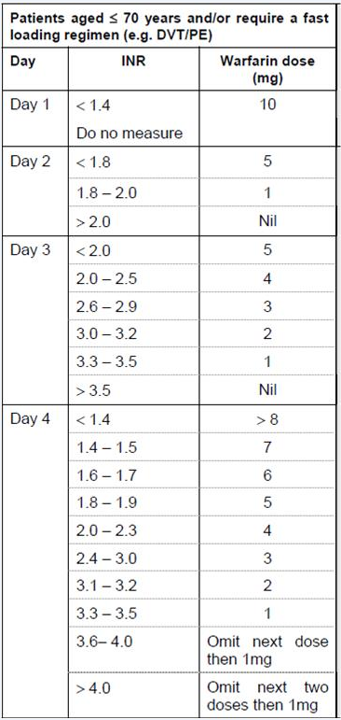

Switching Anticoagulants

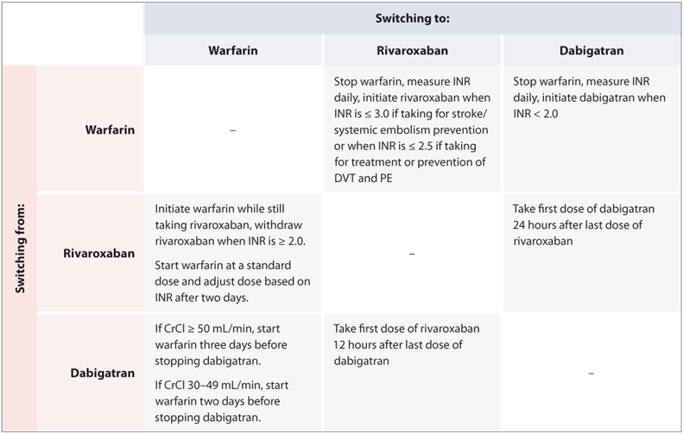

Patient Unsuitable for Anticoagulation
Refer to on-call AAU specialist (Mon-Fri, 9-5, 06 8734812) if:
- Heparin induced thrombocytopenia
- Contraindications to anti-coagulation therapy include:
  - haemophilia or any other known bleeding disorders
  - active bleeding
  - platelets <75
- Pregnancy If outside these hours, call the medical registrar through the hospital switchboard.

Refer to Haematologist
Refer to Haematologist for advice/assessment if:
- Above knee DVT
- Second event
- Large, spontaneous clots
Ongoing Management
- For trauma or surgical patients presenting with a DVT, three months treatment should be sufficient, with GP review at the end of this period to determine discontinuation
- For below knee DVTs, treat for three months and review before discontinuation
Dual Antiplatelet Therapy

Patients who are on both clopidogrel and aspirin, or ticagrelor and aspirin should be discussed with the on-call medical team prior to treatment.

