Health Hawke’s Bay Men’s Health Networking Breakfast November 22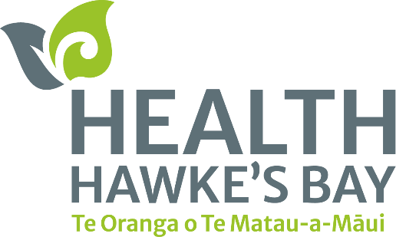

**Prioritising Men’s Health**

*Health organisation promoting Men’s Health Awareness Month*

Health Hawke’s Bay supports the national change of face for Men’s Health with a Networking Breakfast event in Te Matau-a-Māui.

In support of Men’s Health Awareness Month and the Movember initiative, Health Hawke’s Bay invites all tāne across the rohe to connect and kōrero at Toitoi Arts and Events Centre in Hastings tomorrow from 7am to 9.30am.

The event will start with a buffet breakfast where the team will discuss various health challenges our tāne face and explore opportunities for how our tāne can be better supported and cared for. This includes a kōrero from Paralympian Peter Cowan, a bronze medallist from the 2024 Paris Paralympics.

Health Hawke’s Bay’s Director of Hauroa Māori Henry Heke says the event is a really great opportunity to bring our tāne together, something that we often don’t do, especially to talk about our health and wellbeing.

“It’s not a new concept that our tāne often won’t talk about their emotions, or how they’re feeling, and we want to change that narrative. We have options available to support them, so creating these networking events is one way we can help break down the barriers and open avenues of care.

“Normalising talking about health is our goal, making sure our men can get support and care if they need it. This event is our way of supporting the Movember global movement, and we’re proud to be able to take part” he said.

Tickets are limited and are $45 available EventFinda. This goes towards the cost of the breakfast, and any proceeds will be donated to the Movember Foundation NZ which will continue to support initiatives across the motu.

“We are looking forward to connecting with our community and hearing from our guest speaker, who is a keen advocate for health and movement and has an incredible story to share on never giving up” says Heke.