Health Hawke’s Bay are making surplus funds available to providers to support with one-off, innovative ideas.  Please complete and send all applications for consideration to jude.mcrae@healthhb.co.nz, we will have a panel consider applications at the end of each month until the funds are distributed. | Author:  Including provider name

Date:
 | Kaupapa:
He whakaaro:  Some things to consider while you are writing your application:  - How does this Kaupapa align to Ka Hikitia and the four pou?  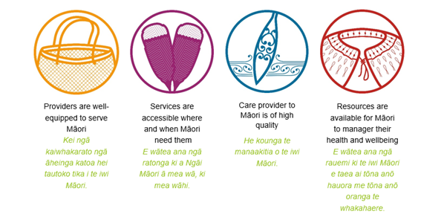  - What proposed outcomes are there for our whānau?  - What problem are we trying to solve? How do we know?  - What opportunities for future growth and development can we see emerge from this Kaupapa? | Key Principles of the HHB Innovation Fund  - Opportunities should be one-off investments and not intended as sustainable and ongoing funding.  - Kaupapa should aim to be equity focused and have Māori health outcomes as their focus.  - Both internal and external projects could be considered  - An identified need should be met, this need should be evidenced.
TE PŪTAKE (Where the idea came from?)
The why, What need could this idea meet? How do I know there is a need? Where else is this being done?

TE KAUPAPA (Tell us about the innovative idea)
Details here of who, what, where, how etc.

NGĀ HUA E PUTA (What will come out of this work?)
What outcomes are we investing in, how will we know we have achieved these?

