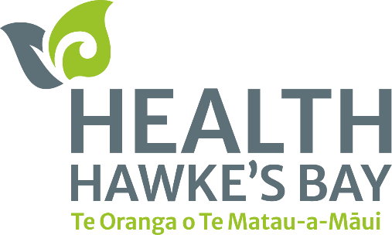**Health Hawke’s Bay Wānanga**

**Te Huki Marae, Raupunga, Wairoa District**

December 11, 2024

Taku rekereke, taku turangawaewae

Where I dig my heels in is where I make my stand.

Health Hawke’s Bay | Te Oranga o te Matau-a-Māui took the opportunity to meet kanohi-ki-te-kanohi with the Raupunga community.

The wānanga was an opportunity for kaimahi to connect with members of the community, to help better understand their health needs, and their aspirations for their community health into the future.

During the two-day wānanga, staff from the organisation stayed overnight at Te Huki Marae in Raupunga, with over 40 staff and whānau sharing the wharenui space.

After a wairua filled pōhiri on Thursday morning, staff learnt more about their whakapapa and meet Te Huki Haukāengawith plenty of kōrero during the whakawhanaungatanga.

Irihāpeti Mahuika, Health Hawke’s Bay’s Pou Whakarae Chief Executive Officer said the connection to the community is important to ensure we deliver services in an effective way.

“Health Hawke’s Bay’s Ka Hikitia | Priority Strategy is our core strategy for achieving equitable health outcomes with Māori, our priority population.”

The wānanga allows staff to listen to whānau and understand what their aspirations and needs are, and then return with some feedback and potentially solutions.

“Having wānanga around Hawke’s Bay including Wairoa allows us to understand what the health needs are for our people and build strong relationships with the community.”

Te Huki Haukāengamade sure to share their knowledge of Ngāti Pāhauwera and Te Huki Marae with plenty of kōrero on Thursday.

Whether it was learning about internationally renowned Pāhauwera artist Sandy Adsett’s paintings and carvings in the wharenui, or how Te Huki was based in Waihua, had travelled and settled in Raupunga, Health Hawke’s Bay staff had an abundance of knowledge shared with them. On Friday, kaimahi had their leg muscles and lungs tested with a hīkoi up Tawhirirangi maunga in Mohaka.

From there, Kahungunu Executive’s Vilma Hape (or locals if she does not want to be named) shared her knowledge on the whakapapa of the whenua.

This included kōrero on Mohaka Harara, Taupunga, Ōpunga Taupunga and Opunga the treasured hangi stones of the Mohaka River.

For Health Hawke’s Bay’s Communication Advisor Ryan O’Sullivan, the wānanga was a grounding experience.

“A lot of the feedback from staff on this wānanga was how comfortable they felt during their stay and the hospitality was recieved.

“From the moment the pōhiri began, we felt a connection to the land and the people were so welcoming towards us.

“Whether it was taking in the kōrero about the marae, a visit of the Mohaka Viaduct or acknowledging the work of our staff over the past year, there was a highlight taken from everyone in attendance.”

The Primary Health Organisation aspires to visit every marae in the district during their wānanga events.

“We are hoping to visit as many marae in Hawke’s Bay as practical and possibly including the Wairoa district.

Two years ago, the organisation visited Tuahuru Marae in Te Māhia and Te Huki was their second marae visit in the Wairoa district.

“We are looking forward to returning to the rohe for wānanga in the future.”

**END**

