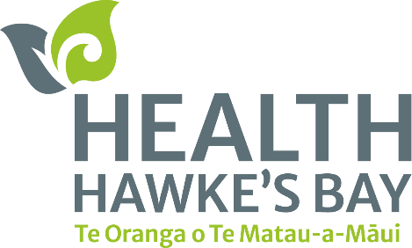**Men’s Health Networking Breakfast**

December 3, 2024

‘Open up not harden up.’

That was one of several key messages shared at Toitoi Arts and Events Centre on Thursday morning when our Te Pou Tawa | Māori Health team held a Men’s Networking Breakfast for over 70 tāne.

The breakfast was a chance for tāne across the rohe to hear from some of our HHB staff and key mental Health Hawke’s Bay icons open up on their health journeys, ā-tinana, ā-hirikapo hoki.

Whether it was losing weight to spend more time with their tamariki, health coach and mental health services support, or kōrero on dealing with ‘shit in your bucket’, there was something for every attendee to relate to.

If the speakers with open and honest kōrero was not enough to full the appetite, there was a sizzling buffet breakfast of sausages, bacon, eggs, hash browns and croissants available to eat.

The networking event was a great chance for our staff to hear what health challenges our tāne face and what improvement’s they like to see.

This was done with a mini workshop with our tāne writing down answers to some pātai we shared with them.

To make sure our tāne were networking, we made sure to get them to move around to different tables and meet new people.

We received excellent feedback on:

* What type of health services or wellness programmes they would like to see in the workplace;
* What barriers they encounter when trying to access health services;
* What health education or information they would find beneficial;
* What the biggest challenges they face in managing their health.

The feedback from those who attended was so good that we have some exciting news we want to share – we will return with another Men’s Breakfast event in 2025 so look out for it!

We would like thank all attendees for taking their time to join us, our speakers at the event, our Te Pou Tawa team for organising the event, Toitoi for hosting us.

All the proceeds from the event will go to Movember – a worldwide organisation that uses donations to run health programmes to support tāne with their health.

For more on Movember visit their website [here](https://nz.movember.com/).

To view more on how one of our health services has supported one tāne in Hawke’s Bay, view our Kia Ora video [here.](https://www.facebook.com/100071108124677/videos/864697889164318)