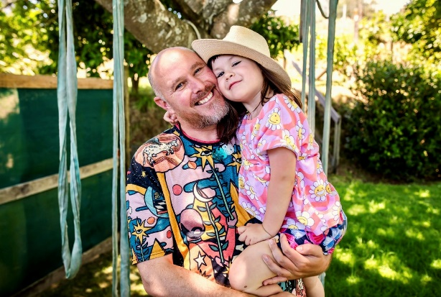

**Alex Barnes (PhD)**

Herea ngā aka o te Tiriti o Waitangi

Kia tupu tai kaha te tupu o te rakau

Kia tupu tai kaha te māra o mātauranga

Morimori te tupu hei whakamaru i ngā tāngata katoa

Rire hau

Rire hau

Paimārire

**Ko wai ahau**

Kei ngā mana, tēnā rā koutou katoa.

My name is Alex Barnes. I am a Pākehā pāpā and product of the kaupapa Māori education movement through my families involvement in kōhanga reo and kura kaupapa.

I have affiliations to Mātaatua, Tainui and Te Tai Tokerau regions through my ongoing involvement in kaupapa Māori movements and my daughter Hautonga Mary Hotere-Barnes (Ngāti Maniapoto, Te Aupōuri, Te Rarawa, Ngāti Wai, Europe). I live in Kirikiriroa and Tainui.

To keep my vibe right I hang out with my daughter, friends and family; listen to music; meditate; exercise; watch basketball; do voluntary community work; and review [podcasts for Radio NZ.](https://www.rnz.co.nz/tags/Alex%20Barnes)

**Ngā pūkenga me ngā wheako**

Te Tiriti o Waitangi is my touchstone personally and professionally. I draw on te Tiriti as a way to understand and work with a diverse set of kaupapa Māori and non-Māori groups, individuals and organisations.

I have worked on a range of kaupapa Māori health, education and environmental initiatives:

* **Kaupapa Māori - by Māori, for Māori**: I work with diverse Māori groups to advance the wider kaupapa i.e. at a strategic or practical level
* **With “Tangata Tiriti”:** I work with non-Māori about how best to create and foster productive relationships with Māori.
* **A two-worlds approach:** I explore the power-sharing relationships *between* Māori and non-Māori to draw on mātauranga Māori and Western worldviews, values, and concepts to advance wellbeing and hauora.

I’m curious about what supports and gets in the way of people being, talking and acting with each other as opposed to past each other. My PhD explored co-governance education in Aotearoa.

**Te Rau Ora, Te Rau Rangahau**

I am currently the He Rau Rangahau (Research Manager) with Te Rau Ora. Te Rau Ora develops and sustains a Māori health workforce to effectively contribute to Māori Health & Wellbeing.

Kei ngā maunga whakahī, kāti au i konei.

Tēnei te ngākau whakaiti e mihi ake rā ki a koutou katoa.

Nāku iti nei me ngā manaakitanga,

Nā,

Alex

If you’re interested below is more about me and some of my recent work.

**“Pākehā Paralysis” / Pākehā responses to Te Tiriti o Waitangi**

* [TedX](https://www.youtube.com/watch?v=0uOT15h4-7Y)
* [Land of the long white cloud series](https://www.rnz.co.nz/programmes/land-of-the-long-white-cloud/story/2018721662/land-of-the-long-white-cloud-episode-4-pakeha-paralysis)
* [Practice Foundations: Tangata Tiriti](https://www.youtube.com/watch?v=VwSSY7YuKDo)
* [Te Tiriti o Waitangi and Anti-racist Activism](https://www.youtube.com/watch?v=ATBAC8C35ik)

**PhD**

* [Thesis: Te Toka Whakaaea: Co-governance education in Aotearoa-New Zealand](https://openrepository.aut.ac.nz/items/4b026691-6723-49d7-8540-21dfec64af69)
* [Brief article: Conceptualising co-governance in education](https://theeducationhub.org.nz/conceptualising-co-governance-in-education/)

**Podcasts:**

* [Taringa](https://www.facebook.com/Taringapodcast/videos/this-week-we-celebrate-our-300th-episode-this-achievement-is-due-to-the-support-/863663748521133/)
* [Toitū te Tiriti: A Pākehā Perspective](https://www.themiddlespace.co.nz/podcast/blog-welcome-65bkn-ncy6y-meaef-cs2zn-lf2gc-6e8ac-9ypbb)
* [Co-governance education, walking between worlds and growing peace](https://open.spotify.com/episode/2tp5FBhqdp77r6yJWmqIwZ)