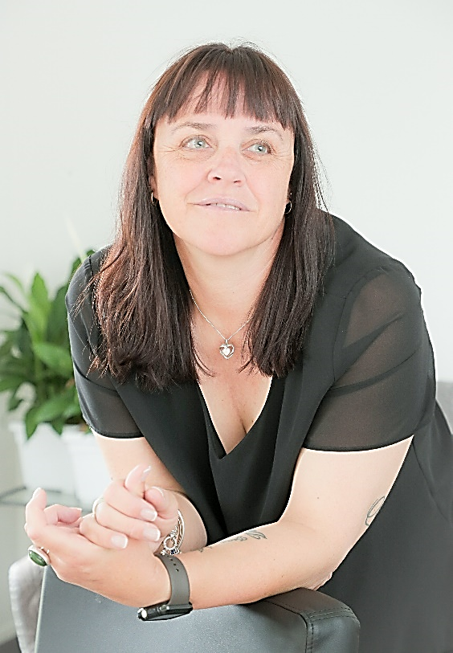

Helen August MN

Nurse Practitioner | Mātanga tapuhi

Child Health Team

Accredited Forensic Examiner (SAATS)

Clinical Lead - Prescribing in Community Health

Whanau & Communities Group / Te Matau a Māui Hawke’s Bay

January 2025

Health Hawke’s Bay Symposium 2025

After completing a Master of Nursing in 2012 my passion for working with youth in the community inspired to complete my Nurse Practitioner qualification which I accomplished in 2018.

Now as a Nurse Practitioner at Health New Zealand Te Whatu Ora Te Matau-a-Maui, Child Health Team and sexual health I work with children and youth predominantly in the community. I am an Accredited Forensic Examiner for adolescence and adults on the acute roster for the Sexual Assault and Assessment Team (SAATS). I have recently just completed 3 years as an on call Police Medical Officer and was the Communicable Disease Coordinator for Hawke’s Bay DHB. I developed and am the clinical lead for the Registered Nurse Prescribing in Community Health Course in Hawke’s Bay. In 2024 I was a speaker at “Don’t forget the Bubbles” international paediatric conference and also spoke at the 2024 Nurse Practitioner conference. I have had a recent educational focus article on scabies published in the NZ Child & Youth Clinic Network newsletter Summer Edition 2024.

My passion is to raise awareness of preventable and early management of skin problems with a specialist interest in eczema management of paediatrics and adolescents whilst providing appropriate education and visual resources to families/whānau on how to care for their skin, prevent skin infections and infestations, identify problems early, treatment, and reduce stigma for tamariki with skin concerns specifically in our lower socioeconomic population. My overall vision is to increase collegiality and enable our RNs to work to the top of their scope and close equity gaps which will then reduce Ambulatory Sensitive Hospitalisation (ASH) rates within Hawke’s Bay and provide equality of care and services to our population who need this most.

**Paediatric eczema**

“I’ve tried everything” “It keeps coming back” “Nothing works”

These are all too familiar comments on the first appointment when it comes to eczema. Parents and patients are challenged by this chronic disease and they are not the only ones. Eczema is often difficult to manage as it is seen as an acute condition and consultation time is often limited. Parents and patients need time to help support and reinforce the health literacy that is imperative when dealing with this disease. Nurse Practitioners particularly in Primary Care or Community Care facilities are well placed to assess, treat and provide the ongoing management and whanau support that is needed to help parents and patients manage this condition.

Prevalence has increased threefold over the last 30 years, and will affect up to 25% of Māori and Pacific people who often present with more sever disease. There is a huge financial and social burden on families if this disease isn’t well managed. This talk will give an explanation of what eczema is which will allow the health practitioner to share this with parents and patients making the treatment plan more understandable. I will share the tools and resources available to support the clinician and the patient in decision making and ongoing management.

The good news is eczema is manageable and treatment can reduce morbidity. Come along on this journey and improve your current understanding of eczema, which will support you to deliver “simply the best” healthcare that we can in regards to eczema.