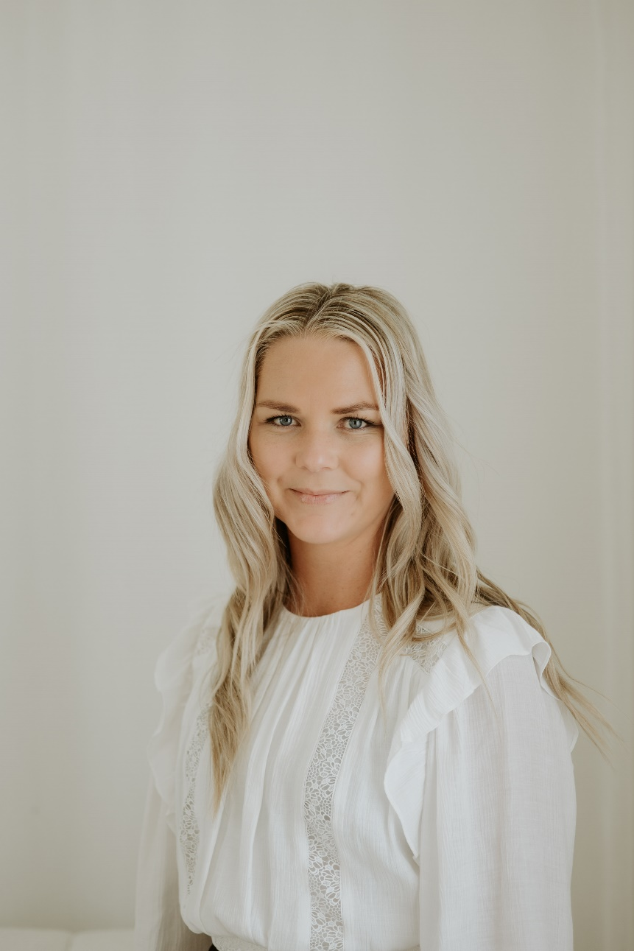**Jess Morgan-French** is a passionate advocate for equitable and timely care for whānau within primary care, with a strong commitment to the principles of Te Tiriti o Waitangi. Based in Tai Tokerau, Jess brings extensive expertise in PHO management, operations, and the practical implementation of the Healthcare Home model.

As a key leader at Collaborative Aotearoa, Jess combines her deep sector knowledge with a keen interest in harnessing digital technologies, including artificial intelligence, to enhance primary care delivery and improve health equity. She is passionate about leveraging innovation to create meaningful change and streamline care pathways for whānau across Aotearoa.