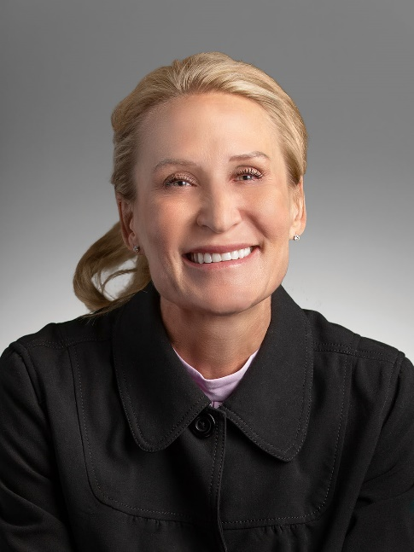
Karoliina Slack
Vice President of Operations
Sanford World Clinic
Karoliina Slack is a seasoned health care executive with a robust background in global healthcare leadership and strategic operations, committed to advancing quality and efficiency within the industry. With a wealth of experience in leadership roles, she brings a comprehensive understanding of the healthcare landscape.
Karoliina is passionate about clinician well-being, leadership development, and creating a resilient culture in medicine. Karoliina believes we can support clinician well-being and combat burnout by changing our mentality about what matters: -Providing quality care -Focusing on patient satisfaction -Being good citizens -Encouraging leadership -Community engagement As the Vice President at Sanford World Clinic, she plays a pivotal role in transforming healthcare operations and fostering collaboration among stakeholders to enhance population health on a global scale.

Session topic
To offset the intense work environment, teamwork is necessary for healthcare provider well-being and optimal patient outcomes. Healthcare teams are unique because they consist of individuals with different training and backgrounds. However, each person shares the same goal: providing excellent patient care. Given the long hours and high stakes, healthcare teams must develop a sense of community and mutual respect. But how does one foster this camaraderie in such high-stress conditions? Develop emotional intelligence (EI). Studies demonstrate that individuals with higher levels of emotional intelligence are better equipped to manage stress, communicate effectively, and empathize with patients. These traits contribute to more cohesive and efficient healthcare teams.
The objectives:
- define and understand emotional intelligence
- describe the impact of emotional intelligence on personal success, patient care, team culture, and leadership
- understand and assess participants' own emotional intelligence strengths and areas

