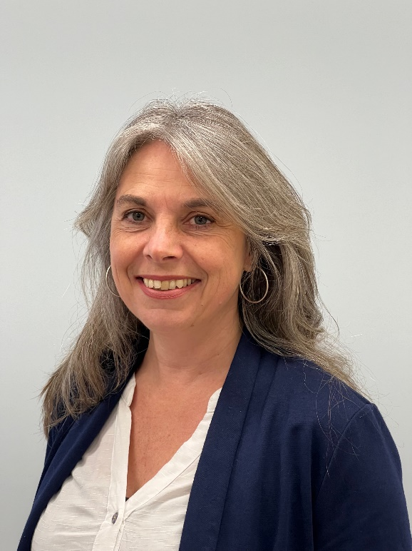

**Speaker Bio**

**Dr Anoek Dechering**

**Consultant Psychiatrist**

**MindMatters Clinic**

**LinkedIn:** <https://www.linkedin.com/company/mindmatters-clinic>

Dr Anoek Dechering is a consultant psychiatrist with over 20 years' experience and specialising in neurodevelopmental conditions across the lifespan, as well as psychological trauma.

Anoek was previously Medical Director for Mental Health and Addiction Services at Te Whatu Ora Health New Zealand and has worked across mental health inpatient and outpatient services, child and adolescent psychiatry services, and emergency mental health services.

Anoek is passionate about a compassionate, pragmatic, and innovative approach to psychiatry.