Radio Kahungunu | Health Hawke’s Bay Collaboration

**Collaborative Effort Aims to Enhance Health Awareness and Education in the Community**

**February 4, 2025**

 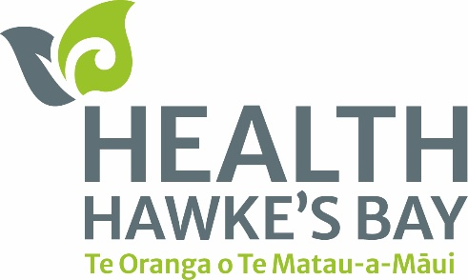

In a collaboration of firsts, Radio Kahungunu and Health Hawke’s Bay are joining forces to broadcast health-related interviews regularly. The partnership aims to promote health awareness and education amongst listeners and the community through the Radio Kahungunu broadcasting service.

Radio Kahungunu is an iwi radio station broadcasting since 1986. Based in Hastings, the station broadcasts content for Māori and by Māori. Radio Kahungunu Producer Lawrence Hakiwai said residents will receive a wealth of knowledge from the health segments.

“It is important we share these services that Health Hawke’s Bay provides so that our whānau can live well and be healthy. We want to share good news stories, and these health messages will allow listeners to know the importance of using health services available to them in their community,” Hakiwai said.

The interviews are also a chance for the station to expand their content.

“We are in the middle of creating a new studio that will allow us to produce content of a higher standard that will have a podcast-like style,” Hakiwai added.

Health Hawke’s Bay is a Primary Health Organisation also based in Hastings and works with General Practices and Pharmacies to provide accessible and quality healthcare services. Health Hawke’s Bay Pou Whakarae | Chief Executive Officer Irihāpeti Mahuika said the collaboration brings a wide variety of benefits to the community.

“Our team and our providers, with their staff members, have a wide range of skillsets and a passion for delivering healthcare to all residents of Hawke’s Bay. I’m excited to share updates about how our organisation is doing with our whānau and inform them of the many services they can access to live a healthy, lasting life,” Mahuika said.

As part of the partnership, Health Hawke’s Bay staff will provide expert health advice, tips, and information to be broadcasted on Radio Kahungunu. The interviews will cover a range of topics, including how to manage long-term health conditions through the Kia Ora programme, how the Primary Health Organisation can help whānau get enrolled, and many more services and programmes the organisation runs.

The initiative is expected to enhance health education and awareness, encourage healthy lifestyle choices, and provide valuable resources to listeners, ultimately contributing to better health outcomes for the community. The first interviews between Radio Kahungunu and Health Hawke’s Bay have taken place with the content available on Radio Kahungunu 765AM and 94.3FM, Health Hawke’s Bay’s Facebook page, and website.