Enrolment Quiz 2024 Circle the correct answers. Answers page 4

- An elderly patient has been visiting family in another province, needed a GP and enrolled in the local Practice. After a stay away for 3 months they are now back home and need to see their GP at your Practice. They ring to book an appointment and you can see that their enrolment has expired as they transferred elsewhere. What do you do?

- Book them in with their GP.
- Roll their enrolment over in the PMS via changing the re-enrolment date to today.
- Explain that they have been unenrolled and need to go through the full enrolment process again with a signed enrolment form.

- A foreign national requests to enrol at your practice. They have a work visa which is one day shy of 2 years, and they tell you they have a long-term condition that needs 3 monthly reviews/ medications. What do you do:

- Enrol them reminding them to let the Practice know as soon as their visa is extended.
- Enrol them only as a casual.
- Tell them to contact the PHO.

- Circle all documents that can be used to confirm identity:
  - Passport
  - Card to access their local gym.
  - Driver’s licence
  - An 18+ card
  - A political party membership card
  - An employment contract or rental agreement
  - Confirmation that the person is receiving a sickness or work seekers benefit.
  - Confirmation that the person has a WINZ emergency benefit.
  - A community services card or SuperGold card
  - A school or tertiary ID.
  - A club membership card

- Circle all ways to confirm eligibility for public services:
  - Passport
  - Card to access their local gym.
  - Driver’s licence
  - An 18+ card
  - A political party membership card
  - An employment contract or rental agreement
  - NZ Citizenship via NES – space is blank.
  - Letters addressed to you at your current address.
  - Confirmation that the person is receiving a sickness or work seekers benefit.
  - Confirmation that the person is on a WINZ emergency benefit.
  - A community services card or SuperGold card
  - A school or tertiary ID
  - A club membership card
  - NZ Citizenship via NES – has “DIA data share”.

- Who can sign the enrolment form? Circle correct answers:
  - The patient
  - A family member
  - Enduring Power of attorney
  - A person caring for someone if there is no Power of attorney enacted and the person is assessed as medically incompetent.
  - The Guardian for under 16 years
  - Enduring Power of attorney where they patient the is assessed as medically incompetent.
  - Flat mate
  - Minister of the church or someone of good standing in the community.

- What year did the new enrolment process become mandatory which included the eligibility checklist, the PHO enrolment, and the need for the patient to confirm they have seen the Health Information sharing document?
  - January 2001
  - May 2011
  - July 2018

- A patient mentions to the GP and the Practice Nurse that they are going overseas to live, and this has been recorded in the notes. What action should occur?
  - The clinical team wish them well and say get in touch if you move back to NZ sometime in the future.
  - The clinical team wish them well, confirm how long they intend to be away and inform the admin team accordingly.
  - The clinical team wish them well and inform the admin team to unenroll them immediately.

- Can you add notes to the enrolment form once it has been signed by the patient?
  - Yes
  - No

- A patient hasn’t been seen for close to 3 years:
  - what do you need to check before re-enrolling them?
- Check you have a complete enrolment form signed and dated.
- Check identity.
- Check eligibility.
- Update demographics.
- Check Visa is current (if applicable)

  - Under what circumstances do you need a new enrolment form?
- If the enrolment form is the older style dated pre-May 2011
- If the enrolment form does not have a clear date and signature
- If there has been a name change
- If the patients address is different now
- If you are unsure about their current eligibility etc.

- How long do you have to get a Baby fully enrolled:
  - 3 months from birth
  - 6 months from birth
  - 9 months from birth
  - 12 months from birth

- A patient requests a copy of their notes to take with them as they are moving overseas next week, and they don’t intend to return for 8 months. What does the administration team do?
  - Provide a copy of the notes and wish them well.
  - Provide a copy of the notes, inform the patient, that as they intend to be out of the country for more than 183 days that they will have to be unenrolled from the Practice.
  - Provide a copy of the notes, note that the patient is going to be out of the country for more than 183 days and put a task in the admin team tasks to check that the patient is still out of the country in 5 ½ months’ time.

If you need further information regarding any of the information above, please refer to the Health Hawkes Bay website:

https://healthhb.co.nz/enrolling-with-general-practice/

Answers on the next pages:

Answers:

- An elderly patient has been visiting family in another province, needed a GP and enrolled in the local Practice. After a stay away for 3 months they are now back home and need to see their GP at your Practice. They ring to book an appointment and you can see that their enrolment has expired as they transferred elsewhere. What do you do?

- Book them in with their GP.
- Change the re-enrolment date to today (roll the enrolment forward)
- Advise they are unenrolled and need to complete an enrolment form.
- Hang up on them.
Answer:
C is the correct answer. Once a person has transferred to be enrolled in another practice they must sign a new enrolment form with your practice, otherwise their re-enrolment is invalid. No matter how long the transfer is!

- A foreign national wishes to enrol at your practice. They have a work visa which is one day shy of 2 years, and they tell you they have a long-term condition that needs 3 monthly reviews/ medications.
What do you do:
- Enrol them reminding them to let the Practice know as soon as their visa is extended.
- Enrol them only as a casual.
- Tell them to contact the PHO.
Answer:
B is the correct answer. Immigration purposely gives work visas for under 2 years for an important reason and this means the person is not eligible for subsidised health services.

- Circle all documents that can be used to confirm identity:
  - Passport (Yes – perfect as this is a photo ID, expired passports are fine too)
  - Card to access their local gym (No – this is not an official identity document)
  - Driver’s licence (Yes- perfect as this is a photo ID)
  - An 18+ card (Yes- this is a recognised Identity card)
  - A political party membership card (No – this is not an official identity document)
  - An employment contract or rental agreement (Yes- HNZ Payments integrity team confirmed this is acceptable)
  - Confirmation that the person is receiving a sickness or work seekers benefit (Yes – WINZ have done the checks for you)
  - Confirmation that the person is on a WINZ emergency benefit (No – these benefits can be used by WINZ for foreigners under extraordinary circumstances who aren’t necessarily eligible for Public health services)
  - A community services card or SuperGold card (Yes – as a last resort but make a note on the enrolment form that no other ID is available)
  - A school or tertiary ID. (No – this is not an official identity document)
  - A club membership card (No – this is not an official identity document)
Answer:
Please see notes above.

- Circle all ways to confirm eligibility for public services:
  - Passport (Yes – this is where you will be able to check if the person has NZ citizenship or the eligible visa- expired NZ passports are fine and can be used to confirm eligibility)
  - Card to access their local gym (No – any foreign person who is not eligible for services can have one of these)
  - Driver’s licence (No – any foreign person who is not eligible for services can have one of these)
  - An 18+ card (No – any foreign person who is not eligible for services can have one of these)
  - A political party membership card (No – any foreign person who is not eligible for services can have one of these)
  - An employment contract or rental agreement (No – any foreign person who is not eligible for services can have one of these)
  - NZ Citizenship via NES – space is blank (No – this means there hasn’t been an immigration data match so there is no evidence here)
  - Letters addressed to you at your current address (No – any foreign person who is not eligible for services can have one of these)
  - Confirmation that the person is receiving a sickness or work seekers benefit (Yes)
  - Confirmation that the person is on a WINZ emergency benefit (No – any foreign person who is not eligible for services can have one of these)
  - A community services card or SuperGold card (Yes)
  - A school or tertiary ID (No – any foreign person who is not eligible for services can have one of these)
  - A club membership card (No – any foreign person who is not eligible for services can have one of these)
  - NZ Citizenship via NES – has DIA data share (yes – see below)
Answer:
Please see notes above and also image of NES below:
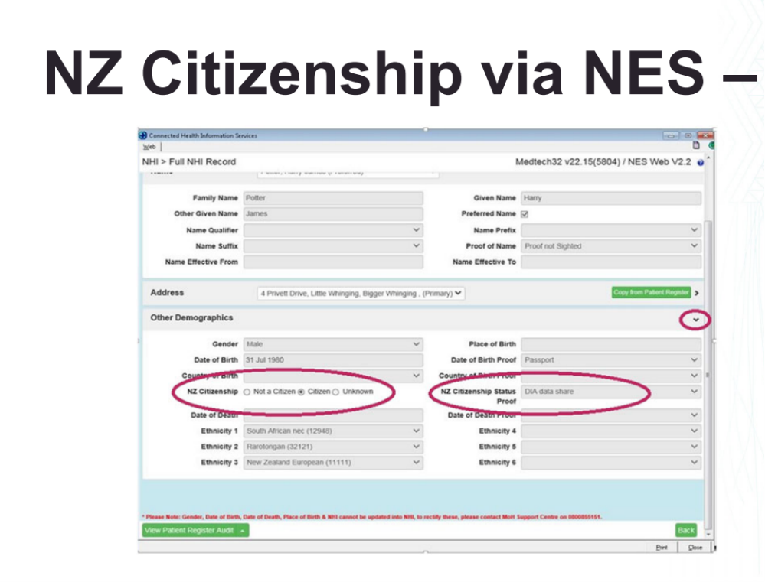

- Who can sign the enrolment form? Circle correct answers:
  - The patient (Yes)
  - A family member (No – unless another answer below applies)
  - Enduring Power of attorney (No- unless another answer below applies)
  - A person caring for someone if there is no Power of attorney enacted and the person is assessed as medically incompetent. (Yes but make sure the reasons are noted on the enrolment form and follow up once EPOA is confirmed)
  - The Guardian for under 16 years (Yes)
  - Enduring Power of attorney where they patient the is assessed as medically incompetent. (Yes)
  - Flat mate (No)
  - Minister of the church or someone of good standing in the community. (No)
Answer:
Please see notes above.

- What year did the new enrolment process became mandatory which included the PHO enrolment and the need for the patient to confirm they have seen the Health Information sharing document?
  - January 2001
  - May 2011
  - July 2018
Answer:
B is the correct answer – this is the year of new enrolment requirements. If you find an enrolment form prior to this, it should be updated.

- A patient mentions to the GP and the Practice Nurse that they are going overseas to live, and this has been recorded in the notes. What action should occur?
  - The clinical team wish them well and say get in touch if you move back to NZ sometime in the future.
  - The clinical team wish them well, confirm how long they intend to be away and inform the admin team accordingly.
  - The clinical team wish them well and inform the admin team to unenroll them immediately.
Answer:
C is the correct answer. If a patient lets the staff know they are intending to live overseas, then they must be unenrolled as are no longer entitled. It is good to remind clinical staff regularly to inform the admin team accordingly.

- Can you add comments on to the enrolment form once it has been signed by the patient?
  - Yes
  - No
Answer:
A is the correct answer. If you have difficulties for example obtaining ID, you can make a note on an enrolment form, but sign and date it. This can be done for older enrolment forms that you may print, add a note and scan and reattach.

- A patient hasn’t been seen for close to 3 years:
  - what do you need to check before re-enrolling them?
  - Check you have a complete enrolment form signed and dated.
  - Check identity.
  - Check eligibility.
  - Update demographics.
Answer:
All are correct.

  - Under what circumstances do you need a new enrolment form?
- If the enrolment form is the older style dated pre-May 2011 (Yes)
- If the enrolment form does not have a clear date and signature (Yes)
- If there has been a name change (No but it can be useful to note this on the enrolment form, date & sign the entry)
- If the patients address is different now (No)
- If you are unsure about their current eligibility etc. (Yes)
Answer:
Please see notes above.

- How long do you have to get a Baby fully enrolled:
  - 3 months from birth
  - 6 months from birth
  - 9 months from birth
  - 12 months from birth
Answer:
As of 1 April 2024, this has been extended to 12 months to support Practices to actively work over a longer period to obtain the babies enrolment. This is to support Immunisation schedules. It is however really important that Practices maintain an urgent response to enrol before 6 weeks.

- A patient requests a copy of their notes to take with them as they are moving overseas next week, and they don’t intend to return for 8 months. What does the administration team do?
  - Provide a copy of the notes and wish them well.
  - Provide a copy of the notes, inform the patient, that as they intend to be out of the country for more than 183 days that they will have to be unenrolled from the Practice.
  - Provide a copy of the notes, note that the patient is going to be out of the country for more than 183 days and put a task in the admin team tasks to check that the patient is still out of the country in 5 ½ months’ time.
Answer:
B is the correct answer. 183 days is the magic number – to be entitled to enrol/ remain enrolled the patient must state an intention to be in NZ for more than 183 days.

If you need further information regarding any of the information above, please refer to the Health Hawkes Bay website: https://healthhb.co.nz/enrolling-with-general-practice/

