CPO Skin Cancer Pathway
The burden of skin cancer is exceeding the resources available. These include triage, dermatology support, timely access to appropriate surgery and histopathology services.
Some skin cancers are life threatening and require timely management, many can be managed medically, and some may never cause concern.
The skin cancer matrix is designed to ensure that significant lesions are managed promptly but that other options are considered for less significant lesions.

Principles of Skin Cancer Pathway
- High Risk Lesions-To be referred, triaged and managed promptly
- Suspected Melanoma - clinical features or on Dermoscopy
- Suspected SCC/BCC T zone
- EFG (Elevated Firm Growing), Keratoacanthoma (size dependent ) lesion or Rare Malignant Tumours
- Other High Risk Lesions Head / Neck or Ears
- Consider if other lesions require treatment at all, e.g. the elderly, rest home and private hospital residents are unlikely to require skin surgery unless the lesion is rapidly growing and symptomatic. Consider observing lesions for change.

- Medical Management is appropriate for all low-risk lesions - see section below.

Please refer to the Decision Matrix and Referral Table prior to sending referrals to the CPO Skin Cancer Pathway.

Decision Matrix

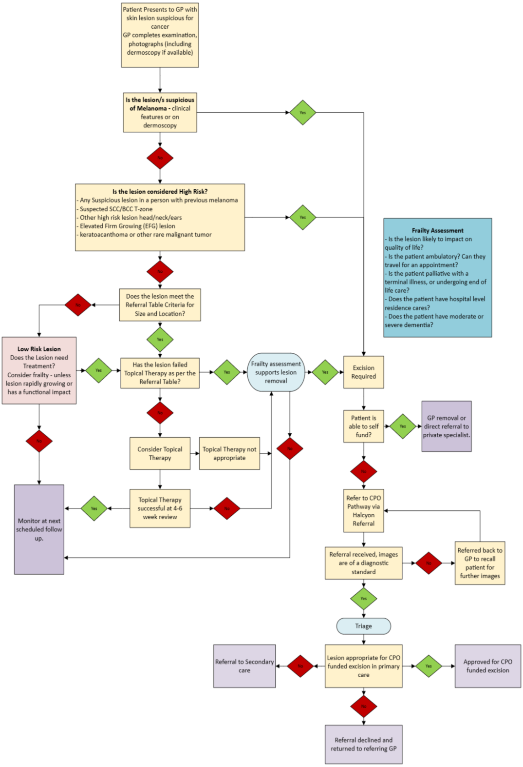

Referral Table
There is limited funding for the Skin Cancer pathway therefore some lesions may be declined, referred to secondary services or referred back to referrer.
Cancer Type
Green: Refer to CPO Skin Cancer Pathway | Red: Decline – Return to referring GP/NP
Suspected Melanoma on Dermoscopy or clinical features suspicious for melanoma.
Rare Malignant Tumours
Suspected SCC/BCC T zone
Keratoacanthoma / EFG (Elevated Firm Growing) lesion (Size dependant- may be returned to referrer due to capacity limitations)
Other high risk areas Head / Neck /Ears
All lesions below must have failed topical therapy
SCC ≥10mm Head/ Neck outside “T zone”
SCC ≥15mm Trunk / arms / upper leg
SCC ≥10mm Hand/ Feet/ Lower leg
SCC insitu Head / Neck (failed topical treatment twice)
BCC >10mm Head / Neck outside ‘T zone’
BCC ≥15mm Trunk/ arms/ upper leg
BCC ≥10mm Hand/ Feet/Lower leg
BCC superficial Head / Neck (failed topical treatment twice)
All other BCC Trunk / Limbs will be referred back for observation
BCC/SCC insitu Trunk / Limbs failing medical therapy will be referred back for repeat medical therapy and observation

Medical Management
Medical management is used first on all other lesions, this is with curative intent but will also clear background field damage and define margins of resistant lesions to simplify surgery (neo-adjuvant treatment). There is no downside to attempting medical management.
- Superficial BCC outside the T Zone and ears, small nodular BCC below the neck:

- imiquimod daily for 5 days each week for 6 weeks, up to 12 weeks for nodular BCC. Consider gladwrap occlusion

- SCC, SCC in situ, also actinic field damage outside the T Zone and ears

- Combination 5FU/calcipotriol: Twice daily for 4 days on the face (including lip/vermillion border), twice daily for 10 days elsewhere. Always treat the entire field, not just the lesion. Arms and legs: consider covering with gladwrap (modified chemowrap). Hands: cover with plastic gloves for at least one hour after application. Always clean skin prior to repeated application.

Efudix and Daivonex Patient Information Leaflet Dec 2025 available here

- Cryosurgery for low-risk lesions, can be followed by medical treatment as above

- Hyperkeratotic AKs: 2x10 seconds freeze/thaw cycle
- small nodular BCCs, well differentiated SCCs below the neck: 2 x 30 seconds freeze-thaw cycle

Lesions which fail medical management, or progress to threshold requiring surgery
  - Self-funding excision is discussed with all patients

  - Those unable to self-fund are referred to the CPO Skin Cancer Pathway. See referral table below

Preventative Skin Management
Regular preventative skin management becomes the norm for patients with actinic damage and prior BCC/SCC (secondary prevention)

  - Encourage sun avoidance, broad brimmed hats, long sleeved clothing, sunglasses, daily sunblock re-applied prior to sun exposure. Daily SPF 50+ Sunblock.

  - Regular field treatment with 5FU/calcipotriol (e.g. annually) and oral nicotinamide 500mg BD (the only exception is women with history of triple -ve breast cancer)

CPO Skin Cancer Excision Pathway

Purpose
To improve access for patients for the removal of high-risk lesions in primary care by accredited General Practitioners.

Access to this service:
- Reside in Hawke’s Bay (not necessarily enrolled patients)

CPO Service Scope:
The primary care CPO Skin Cancer Excision Service specifically covers:
- High Risk Lesions-To be referred, triaged and managed promptly
- Suspected Melanoma - clinical features or on Dermoscopy
- Suspected SCC/BCC T zone
- EFG (Elevated Firm Growing, Keratoacanthoma) lesion or Rare Malignant Tumours
- Other high risk areas Head / Neck or Ears
- Excision of up to two lesions (undertaken consecutively) by an Accredited GP provider.
- Follow up appointment with the Accredited GP provider for removal of sutures and discussion of pathology.
- Surgery through the CPO pathway cannot be offered for very low risk lesions, they are to remain under review at scheduled follow up appointments.
- No surgery can be offered to benign lesions, even if symptomatic

Funding Exclusions:
skin tags | warts/ verrucae
superficial basal cell carcinoma | solar keratoses
seborrhoeic keratoses | benign naevi
lipomas | all other non-malignant lesions
sebaceous cysts | non-healing ulcers - consider biopsy and/or refer to appropriate specialty
chondrodermatitis nodularis helicis ears | pyogenic granuloma
epidermoid cyst | pilar trichilemmal cysts
dermatofibroma | milia
staged procedure | non-surgical management e.g. topical treatment

CPO Skin Lesion Referral
Referral is through the Halcyon Provider Portal > Skin Lesion.

HHB Triage Process:
Patients with lesions suspicious of cancer, requiring surgical removal, can be referred into the CPO Skin Cancer Pathway through the Halcyon Provider Portal. All referrals will be triaged at Health Hawkes Bay and referred either to:
- An Accredited GP provider for excision of the skin lesion.
- CPO Medical Advisor for triage to primary or secondary care or declined, if inappropriate
- Te Whatu Ora-Hawkes Bay if lesions are complex and unable to be completed in primary care
- Returned to referring GP/NP if inappropriate, incomplete information or no photographs received.

Referrals Process
- Check that the patient does not have health insurance or the means to self-fund removal of the suspected skin cancer.
- Make appropriate referrals using the Halcyon Provider Portal and submit electronically. Once the referral has been triaged, you will receive a HL7 message into the provider inbox.
- All referrals to include both close-up pictures of the lesion, along with another image that shows the lesion’s location on the body. Dermoscopic images are highly desirable.
- Referral detail to include accurate measurements
- Biopsy costs are not included in the programme.
- If the lesion is not suitable for excision in primary care, it will be on-referred to Te Whatu Ora-Hawkes Bay. If triaged to Te Whatu Ora, you will receive a HL7 message into the provider inbox. Contact Te Whatu Ora directly with any follow-up queries.

- Incomplete or inappropriate referrals will be returned to the GP/NP.
- If the referral is declined, the referrer will be advised by HHB. The referrer is to advise the patient and follow-up at their discretion.

Photographs

Photographs are required for all referrals. This ensures both the person triaging, and the receiving Accredited GP can plan for the excision without needing a pre-excision appointment with the patient.

- Attach a minimum requirement of 2 different photographs per lesion showing the anatomical location and macro shot/close up of lesion in question with measurement.

- Dermoscopic photo showing clear signs of underlying malignancy are highly recommended in addition to the photographs above.
- If the referral is for a wider excision, photographs of the area including location and close up and are still required.
- Photographs unrelated to the lesion will lead to the referral being declined.
- To attach photographs, you will need to know where your photos are saved in your system, this differs from practice to practice.
- IMPORTANT NOTE: HHB recommends that photographs should not be taken on personal cell phones due to the risk to patient privacy if the phone is lost or accessed by another person. It is recommended that all skin lesion photographs are taken with a practice camera that does not leave the practice.

Multiple lesions:

- A maximum of 2 lesions per individual referral can be accepted. Additional referrals can be submitted by GP/NP for further lesions if required.
• Each lesion which requires surgery needs to be documented separately by photos (see above). Please ensure your photo relates to the lesion it is attached to, rather than putting all photos into one lesion tab.

