Why you are using Efudix and Daivonex
- Efudix cream is used to treat superficial skin cancers or actinic keratosis - rough, scaly patches on the skin caused by long-term exposure to sunlight or UV radiation, which can lead to skin cancer.
- Daivonex ointment is usually used for psoriasis.
- Studies in sun-damaged, rough or scaly skin patches (actinic keratosis) have shown that Efudix in combination with Daivonex works better, faster and causes less inflammation (redness and swelling of the skin), than Efudix alone.

Before You Start
- Wash the skin with tap water and a clean cloth.
- Treat one area at a time (for example, face first, then arms later). This gives time for healing.
- If treating the face; avoid your eyes but include your lip border.

How to Apply
- Mix both creams in your hand and put them on together or first, put Efudix cream on the whole area of sun-damaged skin, then put Daivonex ointment on top. Use about the same amount of the Efudix cream and the Daivonex ointment.
- Do this morning and night:
  - Face: for 4 days.
  - Other areas: up to 10 days, or until inflammation develops.
- Apply like a moisturizer over the whole area, not just spots.
- Cover arms or legs with plastic wrap or hands with gloves for a few hours following application for better results.

How Much Cream to Use
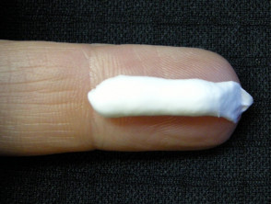
The best way to measure the cream and ointment is using a fingertip unit. This is the amount of cream the covers the length of your fingertip (see picture). For Efudix cream and Daivonex ointment combined, use the following amounts:
- Face and neck: 2.5 fingertip units
- Back of hand: Half a fingertip unit
- Forearm: 1 fingertip unit
- Lower leg: 3 fingertip units
What to Expect
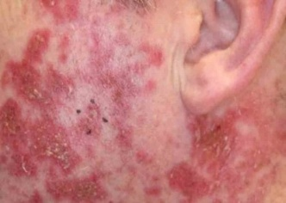
- Treatment destroys cancerous and pre-cancerous cells but has little effect on normal cells.
- From day 5–7, the area of abnormal skin on your skin may become red, dry, flaky, or crusty. This is normal and means the treatment is working.
- After stopping treatment, your skin will need to heal. The treated area may remain red for a while. Healing takes about 1 – 2 weeks.
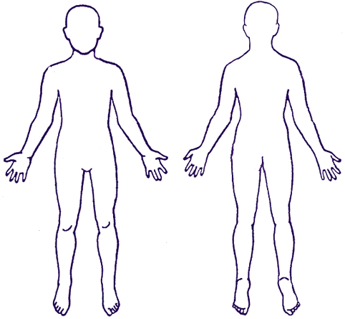
What areas to treat

During Healing
- Wash the area once a day.
- Your skin may feel sore or crack. Use white soft paraffin (like Vaseline) several times a day to stop dryness and help repair your skin.

Repeat Treatments
- Do this course once a year, or more often if your skin is badly damaged.
- Winter is a good time for treatment. Your skin will be very sensitive to sunlight during treatment.
- Review any NEW spots or patches on the skin with your health care provider or skin specialist before treating.

Important Safety
- Efudix can kill dogs and cats. Keep it away from pets.
- You must be well protected from direct sunlight during treatment.
- Store all medicines away from children.

Other medications that may help
- Nicotinamide (Vitamin B3) tablets (500 mg twice a day) can lower skin cancer risk. Nicotinamide is not suitable for people with triple negative breast cancer.
Do not use Niacin (it causes flushing).

When to seek extra help
- If you are feeling generally unwell or develop a fever while undergoing treatment.
- If you have any scaly patches which remain there or enlarge after treatment, see your health care provider or skin specialist.

